Introduction
This documentation is compilation of the information I could gather from MATLAB helpdesk regarding how Simulink works. The mathworks documentation and wikepedia is the reference for this article. This article is for people like me who are humble beginners and does not give any detailed picture. If you are interested just read it and throw away. The article represents my understanding of the working of SIMULINK and it may very well be right or wrong. If not right please offer your humble suggestions and correct me.
My contact details are in MATLAB central file exchange page.
Nitin Skandan

Simulation?
The word simulation implies imitating something in real. This can be a real time process or a physical system. A computer simulation is an attempt to model a real-life or hypothetical situation on a computer so that it can be studied to see how the system works.

Why do we need simulation?
Simulation helps the system engineer or control engineer to analyze the characteristic of a dynamic system (system whose characteristics input, output and states changes with respect to time) without actually having the system in hand. This is extremely helpfully in analyzing the feasibility of such a system before making its real time prototype. Simulation model can be subjected to extreme test conditions that would otherwise be too dangerous in an actual system.

Modeling of dynamic systems
To simulate s system we have to start with its mathematical model. Mathematical model of any system can be derived from fundamental laws of physics. Newtons laws of motion, laws of thermodynamics, Kirchoffs laws in electrical system, laws on hydraulics, and laws on electromagnetic theory.

Physical systems are all continuous time systems. In continuous time system the system characteristics changes continuously with respect to time. Y (t) = f (t). Continuous time systems can be represented by differential equations. For ex:

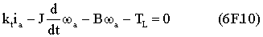

From the above equation you can arrive at a relation between angular velocity (output of motor) and armature voltage (input of motor).

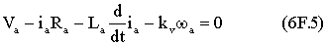

Given a voltage waveform. How will you find the angular velocity waveform?
The answer is to solve the differential equation. Ex:
dy = (x² − 3)dx
Now how to solve the differential equation?
∫ dy = ∫(x² − 3)dx
So you have to integrate it so that differential term vanishes. This will involve one or more integrations. Numerical integration methods are used to solve differential equations.

State space representation
Any differential equation can be converted to a set of first-degree differential equations. An n-degree differential equation can be represented with n first-degree differential equations. Each first-degree equation represents a relation ship between input, output and state variable. These set of equations are represented in state-space form. The input, output and state variables are represented by vectors and differential and algebraic equations are represented by matrices. This is a convenient way to representation for MIMO (multiple input multiple output) systems.
The representation is shown below

Simulink block diagram
Simulink block diagram can be used to graphically represent the equations (any of the three). Block diagrams consist of blocks connected with signal lines. Simulink block diagrams are called time based block diagrams. Note the following points
- Signals are time dependent quantities
- Each block represents an equation linking its input signals and output signals
- Overall block diagram represent time variant relationships between signals and state variables.
Model represents a set of equations representing the dynamic system.

Mathematics of SIMULINK blocks
A Simulink block consists of a set of inputs, a set of states, and a set of outputs, where the outputs are a function of the sample time, the inputs, and the block's states. This is shown below
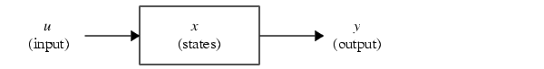
The following equations express the mathematical relationships between the inputs, outputs, and the states for continuous time systems.
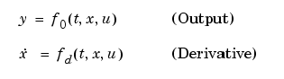

X is obtained by integrating derivative.

So what you can understand from this is that, if you know the values of t, x and u you can find out the values each block output. But how do you know them. U is the block input that is directly read. The issue is t and x.
I will just give some few hints for time being and explain in detail later.

Tcurrent = Tprevious + ∇t (∇t is constant and = sample time of block for discrete systems and for continuous time systems with variable step solver the same comes from solver)

X current = X previous + ∇x (∇x comes from derivative method of the block). This is integration process.

Computing the value of a continuous state at the current time step entails integrating its values from the start of the simulation.

The following equations express the mathematical relationships between the inputs, outputs, and the states for discrete time systems.
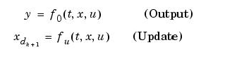
The state x is obtained from state update equation.

In case of hybrid systems there will be blocks with discrete states and continuous states. In such cases step size must be chosen to meet the accuracy requirements of continuous time systems and sampling time requirements of discrete time systems.

An inside look into Simulink blocks
If you have worked with S functions you will probably know what happens inside a block. Each block functionality is realized by a set of methods called as block methods. So each block is a collection of methods (function in program) that are called by Simulink execution engine during model run. Code sections that implement the block functionality are to be added to appropriate methods. We will just see some important methods.
Suppose you are dealing with a continuous time block the important methods are
- mdloutputs (write the code section for computing y )
- mdlderivatives (write code section for computing X dot)
Similarly if you are dealing with discrete block you will have mdlupdate (x update)
When you combine all these methods you will get the state space model of the system.

Simulation sequence
The simulation of model proceeds in stages. First comes the compilation phase. In this phase model is compiled and an executable is generated (involves activities like determining sampling time, parameters, unknown attributes, block sorted order etc). Link phase follows where; model is loaded into memory and allotted space (involves activities like creating method execution lists, taking care of block priorities)
Then Simulink enters a simulation loop, where each pass through the loop is referred to as a simulation step. During each simulation step, Simulink executes each of the model's blocks methods in the order determined during initialization. This continues until the simulation is complete. The figure below shows the different stages of simulation process.

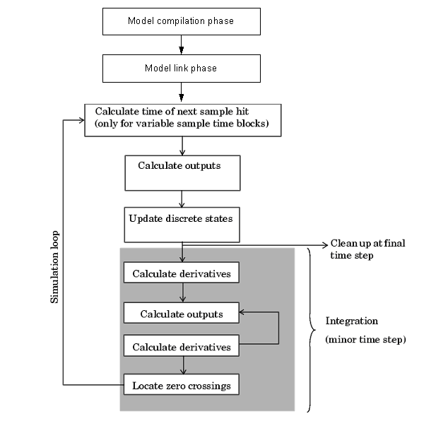

The grey colored section is applicable only form continuous time blocks and update discrete states are applicable only for discrete time blocks. The time for each iteration of simulation loop is based on the step size that is in turn determined by the solver.

A closer look at Simulation loop
Each simulation steps involves the following steps
- Calculation of model outputs
- State updation
- Discontinuity checks (zero crossing detections)
- Compute time for next time step
So that is what it is all about. But still there are many things unclear. Now lets see some issues and throw light on them.
The specific issues are
- How is the time for next hit computed?
- What does that Grey colored block signify?

Lets see what the grey box signifies. If the system under consideration is a discrete system then the grey box is not present in simulation loop. In continuous time system there is concept called major time step and minor time step. Major time step represent the timing of one simulation cycle. Within a major time step there will be a number of minor time steps. The operations performed during these minor time steps are shown in the grey box.
Solvers are responsible for computation of hit instants in all systems and computation of states in continuous time systems.
Solvers are classified as fixed step v/s variable step solvers and continuous v/s discrete time solvers. The selection of solver decides the computation strategy used for simulation. You can choose any combination as you like depending on requirements let see the characteristic of each.

Fixed step solver v/s variable step solver

In fixed step solver the step size is prefixed. So computing of hit time is, current time + time of step size

In variable step solver step size keeps on changing in order to meet the accuracy requirements. The solver keeps checking the derivative value if it is high it reduces the step size to get more points around places of high rate of change and vice versa. This process of checking the derivatives and calculating the outputs happens during minor time steps. The number of minor time steps in a major one turn depends on error. The solvers use standard local error control techniques to monitor the error at each time step. During each time step, the solvers compute the state values at the end of the step and also determine the local error (Don’t know how?), the estimated error of these state values. They then compare the local error to the acceptable error, which is a function of the relative tolerance (rtol) and absolute tolerance (atol). If the error is greater than the acceptable error for any state, the solver reduces the step size and tries again.

Continuous solver v/s discrete solvers

You are already familiar with characteristics of continuous time systems and discrete time systems from the previous sections.

Continuous solvers use numerical integration to compute a model's continuous states at the current time step from the states at previous time steps and the state derivatives. Continuous solvers rely on the model's blocks to compute the values of the model's discrete states at each time step. Mathematicians have developed a wide variety of numerical integration techniques for solving the ordinary differential equations (ODEs) that represent the continuous states of dynamic systems. Simulink provides an extensive set of fixed-step and variable-step continuous solvers, each implementing a specific ODE solution method.
Discrete solvers role is to just tell the time of next hit based on whether variable step solver or fixed step solver is used. Variable solver in discrete model will have effect only in a multirate system (system whose different portions operate at different sample times).

So in the end to sum up the points are
- The total system equation is represented by a model
- Model can represent continuous time system, discrete time system or hybrid systems.
- Hybrid and discrete systems must use continuous time variable step solvers
- Discrete system can used discrete variable step/ fixed step solvers.
- Each block in model represents a mathematical model.
- Solvers do solving of mathematical model.
- Solvers determine the time hit and they compute states in continuous time systems.
- Solvers use numerical integration methods to compute states in continuous time system.
- All the rest of functions and how they are to be done are described via appropriate section in block methods

That’s the idea I am having about SIMULINK. Hope it helps somewhat. Please correct me if wrong. Your comments highly appreciated. My contact address is central file exchange. If you don’t like the article just delete it.

